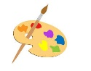
Integrated Arts Schedule- First Nine Week Rotation

Wednesday- 10:30-11:00


Gym | 9/16, 10/7, 10/28
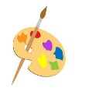  Art | 9/23, 10/14, 11/4
  Music | 9/30, 10/21, 11/11

